Paul Elwood Strauch
October 28, 1915 – April 11, 2004

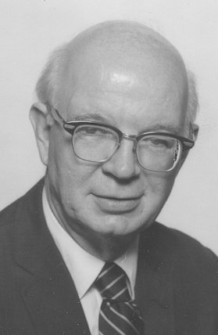
Pleasant Hill, Tennessee – Paul E. Strauch died of pneumonia on April 11, 2004 at the Wharton Nursing Home in the Uplands Retirement Village in Tennessee. Born in Cressona, Pennsylvania, to Lambert and Jennie Strauch, Paul graduated from Cressona High School and Catawba College in Salisbury, North Carolina. In 1941 he graduated from Lancaster Theological Seminary and was ordained into the ministry of the Evangelical and Reformed Church.
On July 13, 1941 he married Melva Kathryn Peifly, his college classmate, in Neffs, Pennsylvania, and they established their home in Freemansburg, where Paul served his first parish. Over the next two decades Paul ministered to the Evangelical and Reformed congregations of Grace Church in Buffalo, New York, and First Church in Takoma Park, Maryland. In 1958 Paul joined the national staff of the Evangelical and Reformed Church, leading the Commission on Stewardship as the Executive Secretary. With the establishment of the United Church of Christ in 1962, he became the Secretary for Christian Education. In 1968 he was called to be pastor of Faith United Church of Christ in New Cumberland, Pennsylvania, and in 1974 served the First Congregational Church in Danbury, Connecticut. Paul and Melva retired to Markelsville, Pennsylvania, and then in 2000 became residents of Uplands Retirement Village in Tennessee. Melva died in 2003.
Paul and Melva raised four sons: John of San Diego, California; Joel of Larchmont, New York; Timothy of Watertown, Wisconsin; and Thomas of Salem, Oregon; and are survived by their sons, daughters-in-law and seven grandchildren.
With Melva’s support, Paul provided leadership in many capacities in their communities. He was active in education serving on the Board of Lancaster Theological Seminary, in urban renewal and housing with Friends Cooperative Housing in Philadelphia and Habitat for Humanity, and in the arts with Perry County Council on the Arts. He pursued many hobbies and interests including gardening, chess, golf, international travel, carpentry, theater, reading, music and playing the cello.
Memorial gifts may be made to the Pleasant Hill Community Church in Tennessee for Christian education.

